Bubble Sort vs Merge Sort
Critical Thinking Assignment 3

Andrew J. Cunningham
Colorado State University Global Campus
CSC506 – Design and Analysis of Algorithms
Dr. Brian Holbert
06 April 2025

Analysis
Bubble sort and merge sort are two sorting algorithms that sort a list of elements in ascending order by a primary key, but utilize different techniques and time complexity.
 | Bubble Sort | Merge Sort
Time Complexity | O(n^2)  iterates through the entire array O(n) n times (n * n) | O(n log n)  Splitting the array in half is O(log n)  Combining the array is O(n)
Spatial Complexity | O(1) conducted in place | O(n^2) as implemented using recursion  O(1)
Stability | Yes – since adjacent elements are swapped, there is no risk of the existing order being disturbed | Yes – comparisons are always made prioritizing the left side of the array, meaning the right is never added first and, thus, the order is preserved
In-place | Yes | No – as implemented
Superior use-case | List is nearly sorted or small | Large, unordered, dataset when extra memory is available

Context and Analysis for Healthcare
When analyzing healthcare databases there are a lot of challenges that we have to overcome:
- The overall database is very large with many complex, interconnected, tables.
- The data is accessed by a lot of customers, all who can mutate the data at any time.
- The data is highly un-sorted.
Assumptions for this sort:
- Working with immutable copy of the data, preventing the risk of manipulation during sort.
- The array will contain the primary_key and the sort_key, rather than the entire data set, which will minimize extra memory requirements.
- Stability is important, healthcare practitioners expect most recent data (date and time) to come first (after consideration for the primary key)
- Memory is essentially infinite. Memory is only a concern on small systems (such as drones or other embedded systems). The healthcare servers likely contain ample memory.

Best choice for Healthcare: Merge Sort
Merge sort is the best choice when considering overall time and special needs. My implementation of merge-sort takes more space, but not enough to be concern on healthcare servers. The time complexity compensates for this, as O(nlogn) is noticeable faster than O(n^2) over large datasets. Lastly, merge-sort meets the stability requirement.

Implementation of Bubble Sort
Bubble sort is an in-place sort that makes linear passes through the array until sorted, swapping adjacent elements as it goes. As each pass is completed we know that the largest element is now on the right side, so the next iteration will not include the right most element. This means that each pass gets one index smaller and we continue passing until the “last” tracker hits the beginning of the array, at which point we know that all of the elements are in order (DSA Bubble Sort 2025).
The two challenges faced was indexing and testing. I’d prefer well-defined loops that make it clear where the start and end points are, rather than simple for loops with single character indexes. So I chose to use a while loop with clear variables. I also had some fun with streamlining the testing code.

Bubble Sort pseudocode
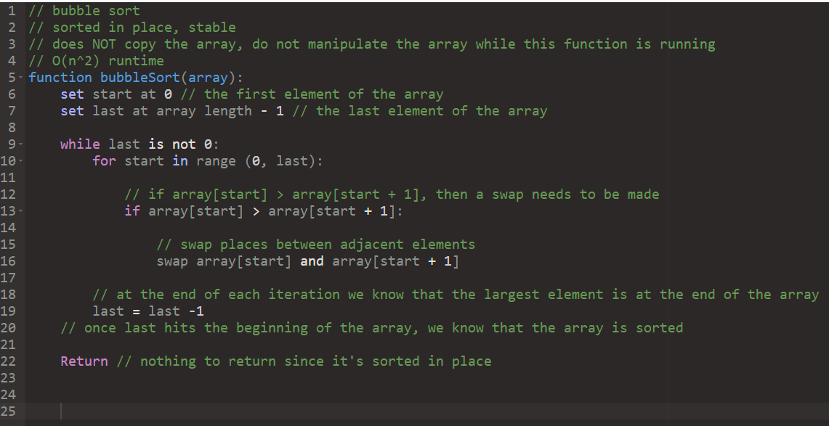

Implementation of bubbleSortAndrew
# Andrew Cunningham
# CSC506 Spring 2025
# Critical Thinking Assignment 3

# implementation of BubbleSort
# Sorted in place, stable, O(n^2) runtime
# does NOT copy the array, make sure the array isn't changed during operation

from typing import List

def bubbleSortAndrew(array):
last = len(array) - 1 # last element of the array

# while we haven't iterated through the entire array n times
while last > 0:
# iterate from the start to our current largest element
for start in range(0, last):
# if the side-by-side elements are out of order, swap them
if array[start] > array[start + 1]:
temp = array[start + 1]
array[start + 1] = array[start]
array[start] = temp
# since we went through the entire array we now know that the largest element is in last
last = last - 1

testArrays = {
"Empty Array": [],
"Single Element Array": [1],
"2 Element Array": [2, 1],
"Worst-cast longer array": [99, 50, 20, 2, 1],
"In order except for middle": [1, 2, 3, 99, 5, 6, 7]
}

for testName, array in testArrays.items():
print(f"Test: {testName}")
print(f" Before: {array}")
bubbleSortAndrew(array)
print(f" After: {array}")

Execution of BubbleSortAndrew
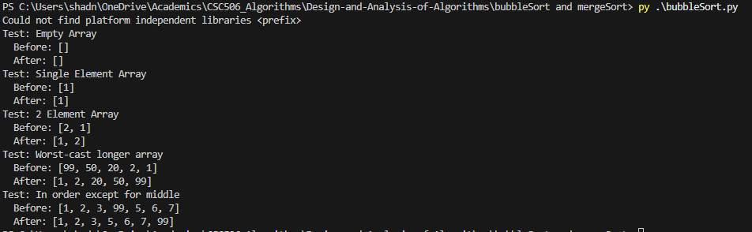

Possible optimization of BubbleSortAndrew
I could have added a flag on each iteration that flags false if no swap was made, if that is the case we could terminate early since we know the array is already fully sorted.

Implementation of Merge Sort
Merge sort is a divide-and -conquer approach to sorting that first acts by splitting an array in half, recursively calling itself for both sides, all the way until one element exists in the array. Then it works backwards, combining the two arrays by iterating over both arrays and building up to the final array by placing the next lowest elements (DSA Merge Sort 2025).
Merge sort can either be implemented recursively or using indexes. I chose to practice recursion because it’s simpler in the context that memory isn’t a strain. Even so, choosing the exact index values and merge strategy is a challenge. I elected to merge prioritizing the left side, but that requires handing the right side in two difference places, for the right side will either run out while processing the left, or afterwards.

Pseudocode of Merge Sort
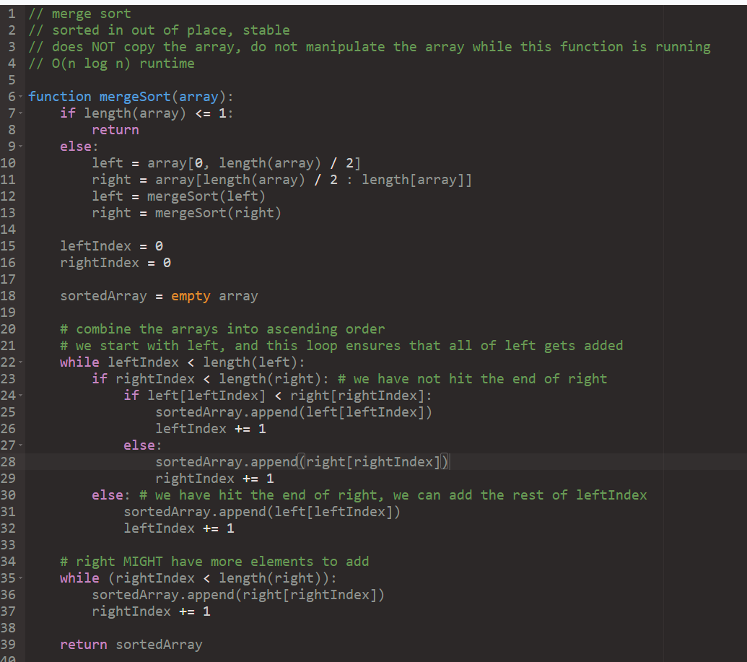

Implementation of mergeSortAndrew
# Andrew Cunningham
# CSC506 Spring 2025
# Critical Thinking Assignment 3

# Implemetion of Merge Sort
# sorted out of place, stable, O(n log n) runtime, O(n^2) spatial complexity

def mergeSortAndrew(array):
# base case: we have recursed to one element
if len(array) <= 1:
return array
# recurse by splitting the array in half
else:
left = mergeSortAndrew(array[0: len(array) // 2])
right = mergeSortAndrew(array[len(array) // 2 :])

leftIndex = 0
rightIndex = 0

sortedArray = []

# start by combining the entire left into sorted
while leftIndex < len(left):
# we have NOT hit the end of right
if rightIndex < len(right):
# see if left is smaller
# <= ensures stability by always adding in left first
if left[leftIndex] <= right[rightIndex]:
sortedArray.append(left[leftIndex])
leftIndex += 1
# right is smaller
else:
sortedArray.append(right[rightIndex])
rightIndex += 1
# we have hit the end of right, so just append it
else:
sortedArray.append(left[leftIndex])
leftIndex += 1

# add the rest of right if applicable
# will attempt to slice an empty list if rightIndex is outside the scope of the array
sortedArray.extend(right[rightIndex:])

return sortedArray

testArrays = {
"Empty Array": [],
"Single Element Array": [1],
"2 Element Array": [2, 1],
"Worst-cast longer array": [99, 50, 20, 2, 1],
"In order except for middle": [1, 2, 3, 99, 5, 6, 7]
}

for testName, array in testArrays.items():
print(f"Test: {testName}")
print(f" Before: {array}")
print(f" After: {mergeSortAndrew(array)}")

Optimizations of mergeSortAndrew
It is possible to implement merge-sort with O(n) spatial complexity and avoid recursion. Instead of copying and recursing an array I could have iterated over indexes (Dadhaniya, 2024).

Merge Sort Output
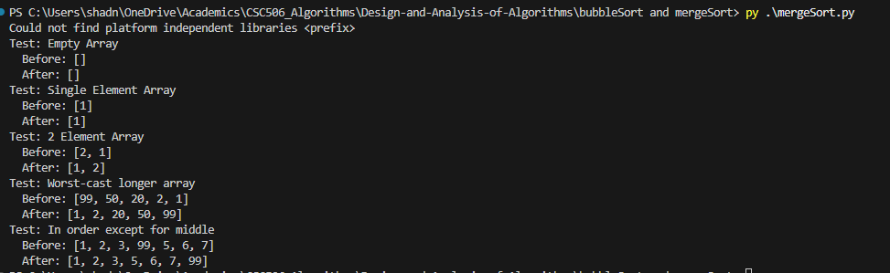

References:
DSA Bubble Sort. W3Schools Online Web Tutorials. (n.d.). https://www.w3schools.com/dsa/dsa_algo_bubblesort.php
DSA Merge Sort. W3Schools Online Web Tutorials. (2025). https://www.w3schools.com/dsa/dsa_algo_mergesort.php
Dadhaniya, D. (2024, September 25). Learn in-place merge sort. Interview kickstart. https://interviewkickstart.com/blogs/learn/in-place-merge-sort

